**Nectar Traffic Control (tc) Control Script for Microsoft**

# I. Requirements

1. The tc_test script is meant to run on any Centos or RHEL 6 and 7 with a minimal install or greater.
2. The script requires Python 2 and the bash shell. Both are installed by default during the minimal install.
3. The user must have root access or have permissions to use sudo.
4. Copy the script to one of the NUCs via SFTP or SCP. WinSCP is a great application to do this from a Windows machine. It can be place in /root (root user’s home directory.
5. To start the script follow the steps below from the directory tcmenu.py is in.
   1. Make the script executable:
      1. *chmod 755 tcmenu.py*
   2. Execute the script:
      1. *./tcmenu.py*

# II. Interface Choice

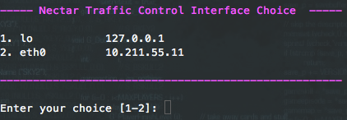

1. When the script is executed the user will be prompted to select the interface that will be used for testing. This can be changed later if needed.

# III. Top Level Menu

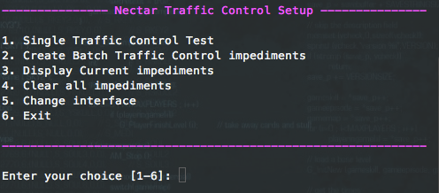

1. Single Traffic Control Test – This allows the user to setup a single set of impediments that will run until cleared by the user. Setting up another Single Test will automatically clear the previous test.
2. Batch Impediments – This allows the user to create a bash script that can be executed to run a series of times impediments. Once the script is created, it can be executed from the command line as root or with sudo by typing *sh <filename>.*
3. Display Current Impediments – This will show the current state of the TC system.
4. Clear all impediments – This will clear the TC system of all impediments.
5. Change Interfaces – Change the interface that is being used for testing.
6. Exit – Exits the script.

# IV. Single Traffic Control Test

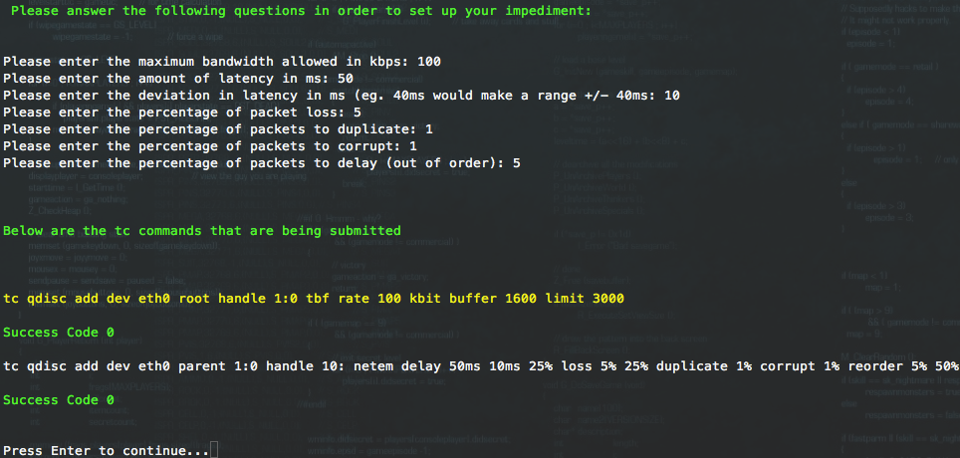

The single traffic control test section will ask a series of questions to gather information on how the impediments should be set up. Once all the questions are answered it will produce the commands that are being submitted for the users reference.

The impediments will continue to run until they are stopped through tcmenu, a new single test is setup, or the script is exited through the menu system. Exiting the script by using a <ctrl> <c> will not clear the set impediments.

The user will be prompted for the following information:

* Maximum bandwidth allowed in kbps – This is the maximum amount of outbound bandwidth available for the system to use.
* Latency – The amount of delay before each packet hit the wire.
* Deviation in latency – Randomly moves the latency setting + or – what is set here.
* Packet loss percentage – The chance that a packet will be randomly dropped.
* Packet duplication – The chance that a packet will be duplicated.
* Packet corruption - The odds that a single bit error will be introduced at a random offset in the packet.
* Percentage of Packets to delay – This sends out of order packets. The percentage entered here is the percentage of packets sent immediately. The rest will be delayed by the latency entry above.

# V. Create Batch Traffic Control

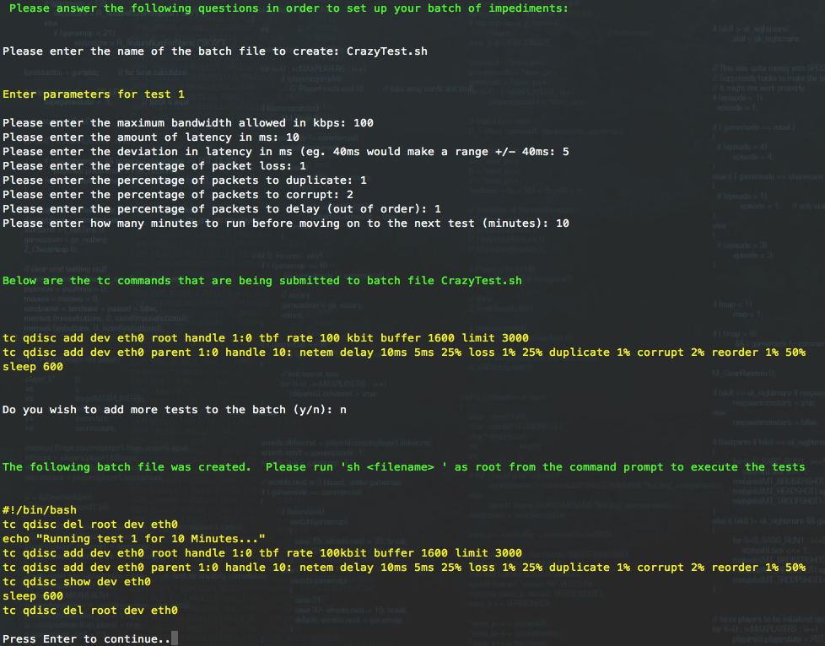

The batch testing option creates a bash shell script with any number of test scenarios included along with timers for how long they should run. The shell script can then be executed outside of tcmenu or moved to other machine for use there.

1. The user must first enter a filename. This is the location where the script will be saved for future use.
2. Next the user will be prompted with all the same questions as the Single Impediment mode (see section IV above).
3. There will be one extra question, how long should the impediment stay in place (minutes). Once this timer expires, the current impediment will be cleared and the next impediment in the script will be used. If there are no more impediments, all impediments will be cleared and the script will exit.
4. After setup the user will be shown the lines that were added to the script.
5. Once all the impediments are entered, the user is shown the contents of the script file.
6. To run the script follow the steps below from the directory where the script was saved.
   1. Make the script executable:
      1. *chmod 755 <script name>*
   2. Execute the script:
      1. *./<scriptname>*

# VI. Display Impediments

This will display the current impediments. If there are no impediments in place this will look something like this:

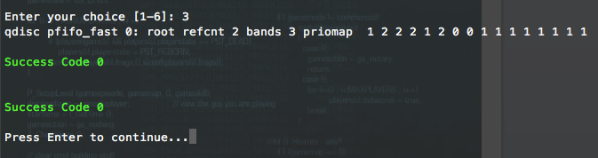

If there are impediments in place it will look something like this:

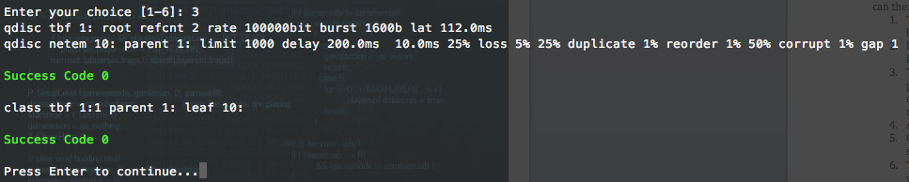

# VII. Clear all impediments

This will clear all the currently running impediments. If there are currently no impediments in place it will return the lines below. This is perfectly normal.

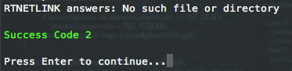

# VIII. Change Interface

This will take the user to the user selection menu from Section I, Requirements.

# IX Exit

This will clean up any configured impediments and exit.